**US Accidents Visualizations**

**QUERY 1:**

with cte1 as

(select state , severity, count(severity) as severity_1 from us_accidents_dec_19_database.us_accident_v3 where severity = 1 group by severity, state),

cte2 as

(select state , severity, count(severity) as severity_2 from us_accidents_dec_19_database.us_accident_v3 where severity = 2 group by severity, state),

cte3 as

(select state, severity, count(severity) as severity_3 from us_accidents_dec_19_database.us_accident_v3 where severity = 3 group by severity, state),

cte4 as

(select state, severity, count(severity) as severity_4 from us_accidents_dec_19_database.us_accident_v3 where severity = 4 group by severity, state)

select a.state, severity_1, severity_2, severity_3, severity_4, sum(severity_1 + severity_2 + severity_3 + severity_4) as tot_accidents from cte1 a

join cte2 b

on a.state = b.state

join cte3 c

on a.state = c.state

join cte4 d

on a.state = d.state

group by a.state, severity_1, severity_2, severity_3, severity_4

order by tot_accidents desc

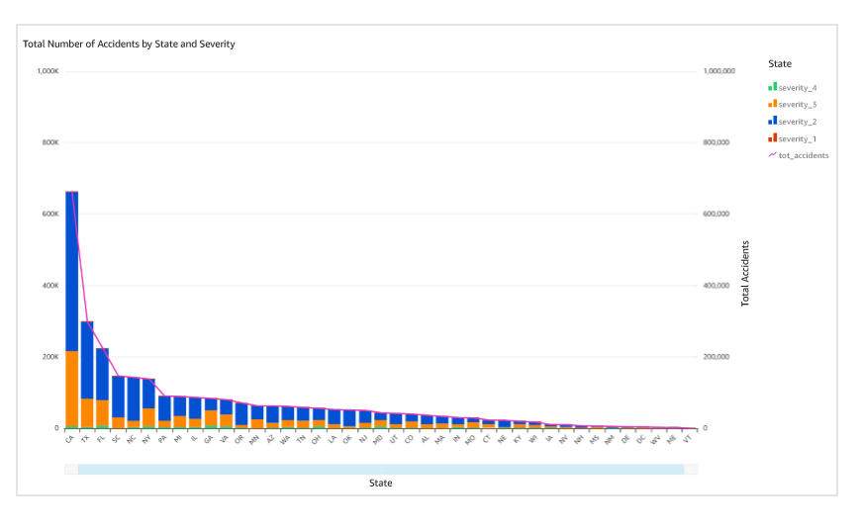

**QUERY 3:**

with cte1 as

(select date_diff('minute', start_time, end_time) as duration from awsdatacatalog.us_accidents_dec_19_database.us_accident_v3),

cte2 as

(select

case

when duration <= 59 then 'minutes'

when duration between 60 and 239 then 'hours'

when duration between 240 and 959 then '4hours_16hours'

when duration between 960 and 1439 then '16hours_24hours'

when duration >=1440 then 'days'

end as duration_section

from cte1)

select duration_section, count(duration_section) as count from cte2

group by duration_section

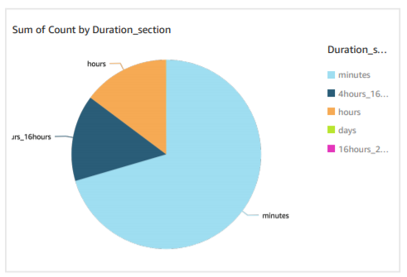

**QUERY 4:**

with cte1 as(

select weather_condition, severity, count(*) as weather_accidents from us_accidents_dec_19_database.us_accident_v2

group by weather_condition, severity

order by weather_condition)

select weather_condition, severity, weather_accidents, total_accidents, cast(weather_accidents as double)*100/total_accidents as perc_severity_accidents from cte1

cross join (select count(*) as total_accidents from us_accidents_dec_19_database.us_accident_v3) b

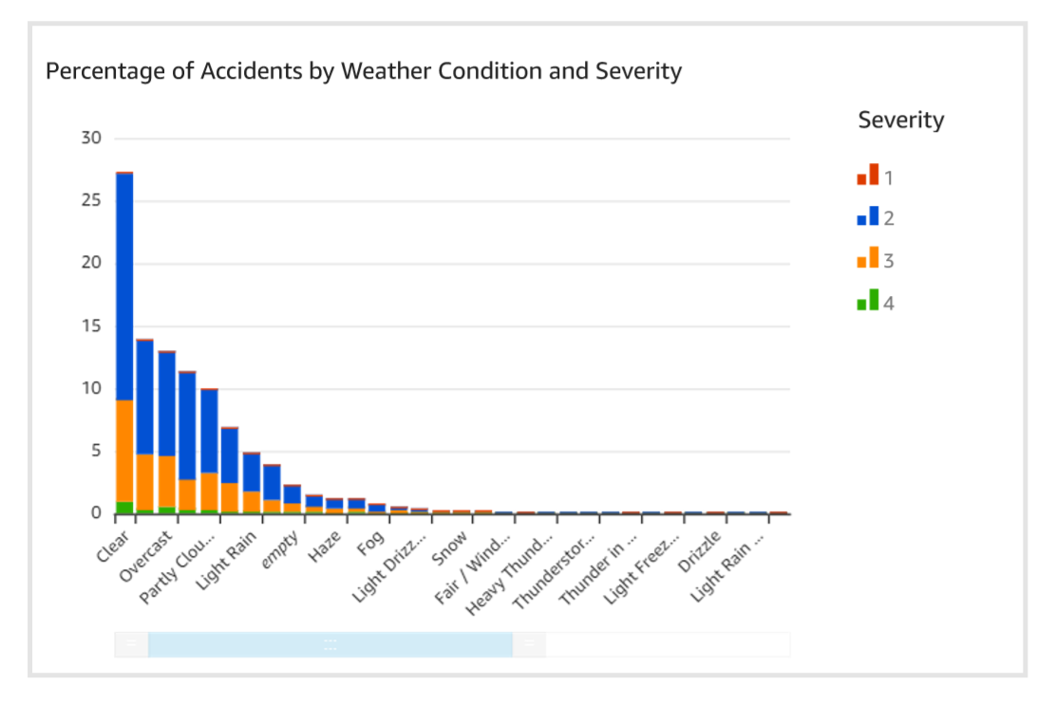

**QUERY 5:**

with cte1 as

(select date_format(start_time, '%Y,%v') AS date,severity,weather_condition,

case

when weather_condition = 'Clear' then 'good'

when weather_condition like 'Cloudy%' then 'good'

when weather_condition = 'Drizzle' then 'good'

when weather_condition = 'Drizzle / Windy' then 'good'

when weather_condition like 'Fair%' then 'good'

when weather_condition = 'Haze' then 'good'

when weather_condition like 'Light%' then 'good'

when weather_condition = 'Mist' then 'good'

when weather_condition like 'Mostly%' then 'good'

when weather_condition = 'N/A Precipitation' then 'good'

when weather_condition = 'Overcast' then 'good'

when weather_condition like 'Partial%' then 'good'

when weather_condition like 'Partly%' then 'good'

when weather_condition = 'Patches of Fog' then 'good'

when weather_condition = 'Scattered Clouds' then 'good'

when weather_condition = 'Shallow Fog' then 'good'

when weather_condition = 'Showers in the Vicinity' then 'good'

when weather_condition = 'Small Hail' then 'good'

when weather_condition = 'Thunder in the Vicinity' then 'good'

else 'bad' end as weather_type,

case

when temperature between -80 and -71 then '-80 to -71'

when temperature between -70 and -61 then '-70 to -61'

when temperature between -60 and -51 then '-60 to -51'

when temperature between -50 and -41 then '-50 to -41'

when temperature between -40 and -31 then '-40 to -31'

when temperature between -30 and -21 then '-30 to -21'

when temperature between -20 and -11 then '-20 to -11'

when temperature between -10 and -1 then '-10 to -01'

when temperature between 0 and 9 then '0 to 9'

when temperature between 10 and 19 then '10 to 19'

when temperature between 20 and 29 then '20 to 29'

when temperature between 30 and 39 then '30 to 39'

when temperature between 40 and 49 then '40 to 49'

when temperature between 50 and 59 then '50 to 59'

when temperature between 60 and 69 then '60 to 69'

when temperature between 70 and 79 then '70 to 79'

when temperature between 80 and 89 then '80 to 89'

when temperature between 90 and 99 then '90 to 99'

when temperature between 100 and 109 then '100 to 109'

when temperature between 110 and 119 then '110 to 119'

when temperature between 120 and 129 then '120 to 129'

when temperature between 130 and 139 then '130 to 139'

when temperature between 140 and 149 then '140 to 149'

when temperature between 150 and 159 then '150 to 159'

when temperature between 160 and 169 then '160 to 169'

when temperature between 170 and 179 then '170 to 179'

else 'temperature unknown'

end as temp_range_in_f

from AwsDataCatalog.us_accidents_dec_19_database.us_accident_v3),

cte2 as

(select *,

case

when severity = 1 and weather_type = 'good' then 'sev1_good'

when severity = 2 and weather_type = 'good' then 'sev2_good'

when severity = 3 and weather_type = 'good' then 'sev3_good'

when severity = 4 and weather_type = 'good' then 'sev4_good'

when severity = 1 and weather_type = 'bad' then 'sev1_bad'

when severity = 2 and weather_type = 'bad' then 'sev2_bad'

when severity = 3 and weather_type = 'bad' then 'sev3_bad'

when severity = 4 and weather_type = 'bad' then 'sev4_bad'

else 'unknown_weather' end as good_bad_sev

from cte1),

cte3 as

(select date,temp_range_in_f,good_bad_sev,count(*) as number_of_accident from cte2 group by date,temp_range_in_f,good_bad_sev

order by date,temp_range_in_f,good_bad_sev asc)

select date,temp_range_in_f, kv1['sev1_good'] as Sev_1_good_weather,

kv2['sev2_good'] as Sev_2_good_weather,

kv3['sev3_good'] as Sev_3_good_weather,

kv4['sev4_good'] as Sev_4_good_weather,

kv5['sev1_bad'] as Sev_1_bad_weather,

kv6['sev2_bad'] as Sev_2_bad_weather,

kv7['sev3_bad'] as Sev_3_bad_weather,

kv8['sev4_bad'] as Sev_4_bad_weather

from (

select date,temp_range_in_f, map_agg(good_bad_sev, number_of_accident) kv1,

map_agg(good_bad_sev, number_of_accident) kv2,

map_agg(good_bad_sev, number_of_accident) kv3,

map_agg(good_bad_sev, number_of_accident) kv4,

map_agg(good_bad_sev, number_of_accident) kv5,

map_agg(good_bad_sev, number_of_accident) kv6,

map_agg(good_bad_sev, number_of_accident) kv7,

map_agg(good_bad_sev, number_of_accident) kv8

from cte3

group by date,temp_range_in_f)

**Good Weather Analysis:**

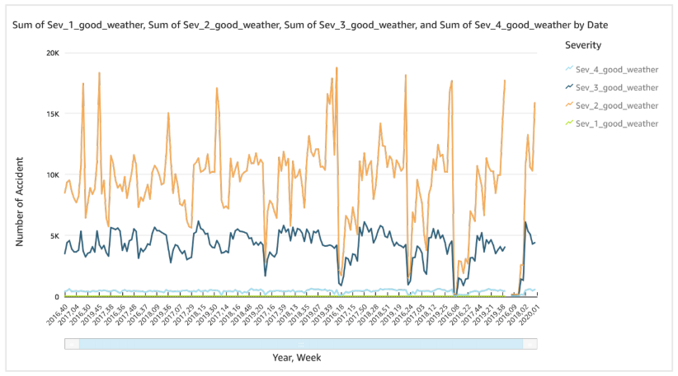

**Bad Weather Analysis:**

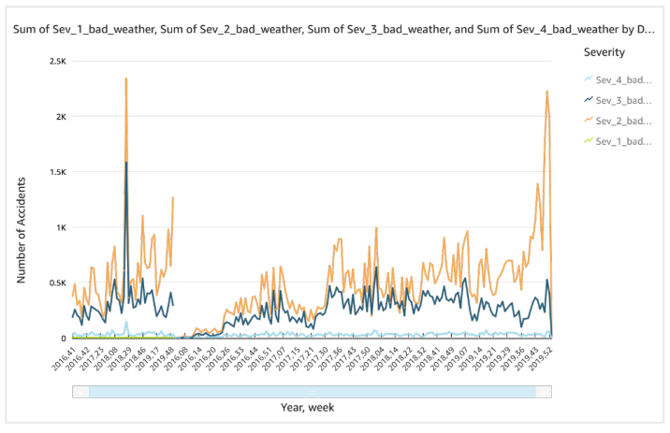

**QUERY 6:**

select date_format(start_time, '%Y, %v') as Year_Hour , severity, count(*) as Total_accidents from us_accidents_dec_19_database.us_accident_v3 group by start_time, severity

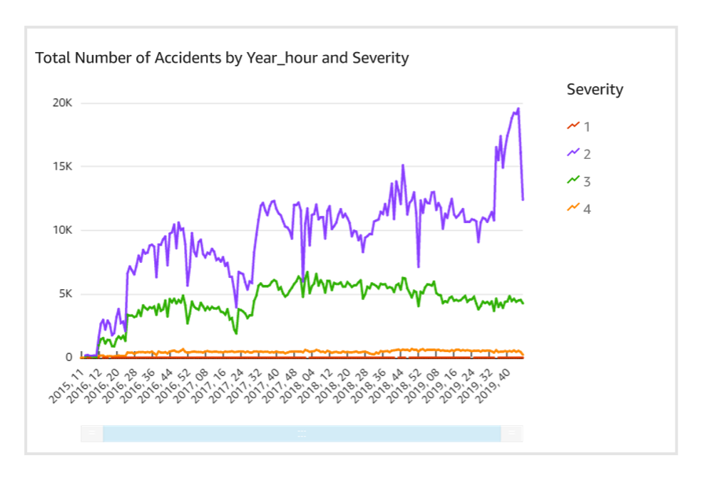

**QUERY 7:**

select severity, avg(distance) as avg_distance, max(distance) as max_distance, round(stddev(distance),2) as std_dev from us_accidents_dec_19_database.us_accident_v3 group by severity order by severity asc

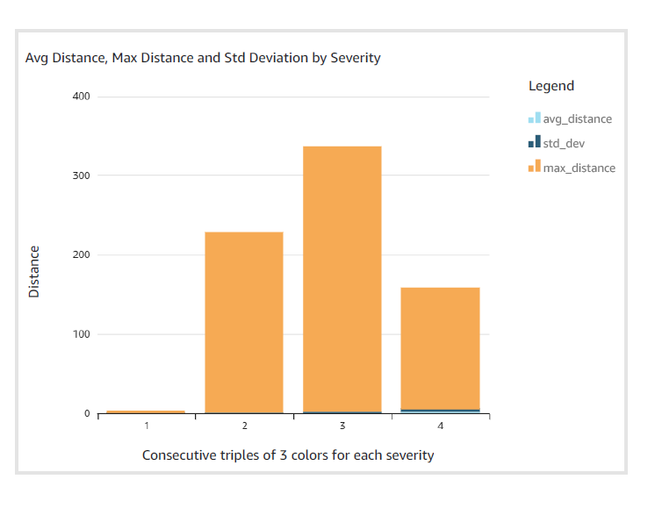

**QUERY 10:**

with cte1 as

(SELECT row, slno,pattrn, concpt, n_description,

regexp_extract_all(lower(a.n_description), (b.pattrn)) AS regexp_group1,

cardinality(regexp_extract_all(lower(a.n_description),

b.pattrn)) car

FROM AwsDataCatalog.us_accidents_dec_19_database.base_corpus3 a

CROSS JOIN AwsDataCatalog.us_accidents_dec_19_database.concept7 b

order by slno)

select distinct(concpt),

case

when slno >=20 and slno <25 then 20

when slno >=25 and slno <30 then 25

when slno >=30 and slno <35 then 30

when slno >=35 and slno <40 then 35

when slno >=40 and slno <45 then 40

when slno >=45 and slno <50 then 45

when slno >=50 and slno <55 then 50

when slno >=55 and slno <60 then 55

when slno >=60 and slno <65 then 60

when slno >=65 and slno <70 then 65

when slno >=70 and slno <75 then 70

when slno >=75 and slno <80 then 75

when slno >=80 and slno <85 then 80

when slno >=85 and slno <90 then 85

when slno >=90 and slno <95 then 90

when slno >=95 and slno <100 then 95

when slno >=100 and slno <105 then 100

when slno >=105 and slno <110 then 105

when slno >=110 and slno <115 then 110

when slno >=115 and slno <120 then 115

when slno >=120 and slno <125 then 120

when slno >=125 and slno <130 then 125

when slno >=130 and slno <135 then 130

when slno >=135 and slno <140 then 135

when slno >=140 and slno <145 then 140

when slno >=145 and slno <150 then 145

when slno >=150 and slno <155 then 150

when slno >=155 and slno <160 then 155

when slno >=160 and slno <300 then 160

when slno = 300 then 300

end as slno,

sum(car) over (partition by concpt) as freq

from cte1 where car>0

order by slno

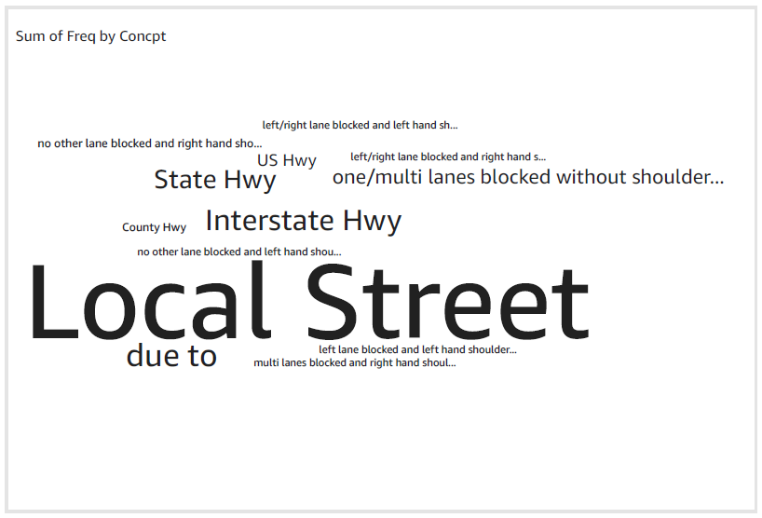

**QUERY 13:**

Top 5 states:

1. **CA**

SELECT DISTINCT state,

hour(start_time) AS hour,

precipitation,

count(*)

OVER (partition by precipitation, hour(start_time), state) AS no_of_accidents

FROM us_accidents_dec_19_database.us_accident_v3

WHERE precipitation IS NOT NULL and state = 'CA'

ORDER BY state, hour desc, precipitation desc, no_of_accidents desc

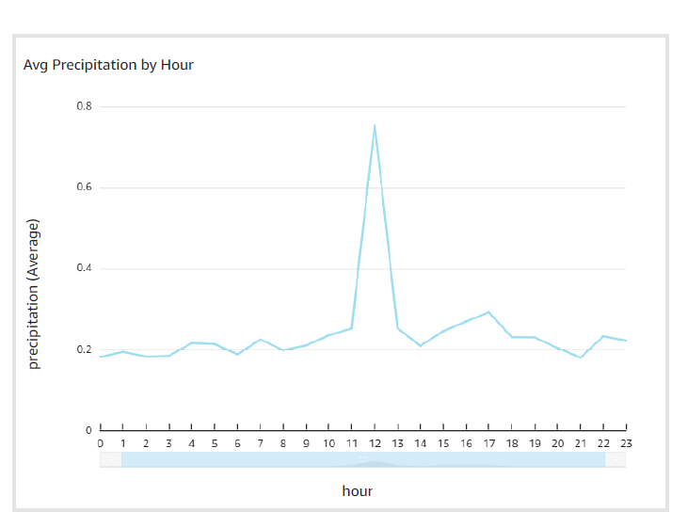

1. **TX**

SELECT DISTINCT state,

hour(start_time) AS hour,

precipitation,

count(*)

OVER (partition by precipitation, hour(start_time), state) AS no_of_accidents

FROM us_accidents_dec_19_database.us_accident_v3

WHERE precipitation IS NOT NULL and state = 'TX'

ORDER BY state, hour desc, precipitation desc, no_of_accidents desc

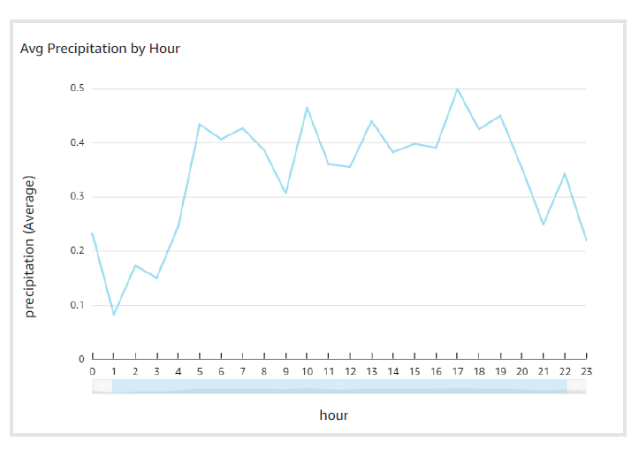

1. **FL**

SELECT DISTINCT state,

hour(start_time) AS hour,

precipitation,

count(*)

OVER (partition by precipitation, hour(start_time), state) AS no_of_accidents

FROM us_accidents_dec_19_database.us_accident_v3

WHERE precipitation IS NOT NULL and state = 'FL'

ORDER BY state, hour desc, precipitation desc, no_of_accidents desc

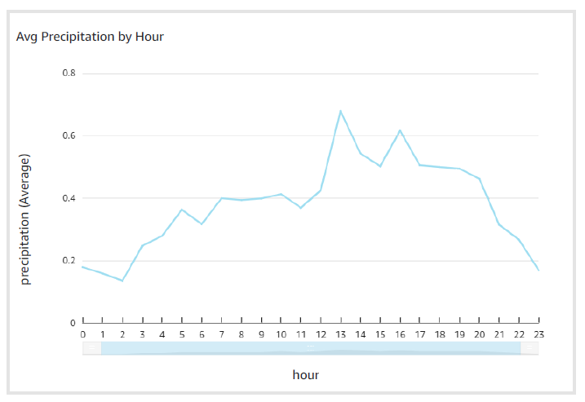

1. **SC**

SELECT DISTINCT state,

hour(start_time) AS hour,

precipitation,

count(*)

OVER (partition by precipitation, hour(start_time), state) AS no_of_accidents

FROM us_accidents_dec_19_database.us_accident_v3

WHERE precipitation IS NOT NULL and state = 'SC'

ORDER BY state, hour desc, precipitation desc, no_of_accidents desc

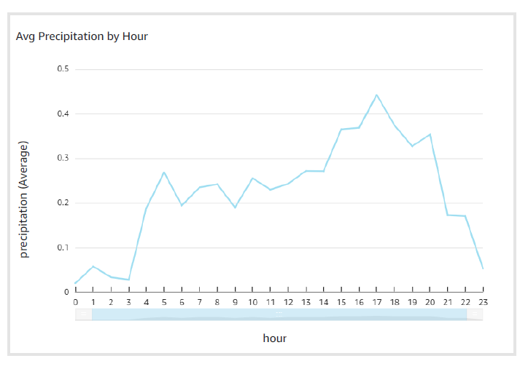

1. **NY**

SELECT DISTINCT state,

hour(start_time) AS hour,

precipitation,

count(*)

OVER (partition by precipitation, hour(start_time), state) AS no_of_accidents

FROM us_accidents_dec_19_database.us_accident_v3

WHERE precipitation IS NOT NULL and state = 'NY'

ORDER BY state, hour desc, precipitation desc, no_of_accidents desc

